
ElectRon and positron collider bunch alignment
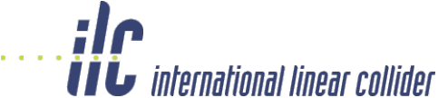

CROSSING ANGLE
Opposing linear accelerators (linacs) accelerate electrons and positrons so they collider at the interaction point (IP). The IP is surrounded by a large detector that searches for new and exotic particles. The electron linac cannot be exactly in line with the positron linac as it is difficult to prevent particles and their associated halos entering the opposing linac.
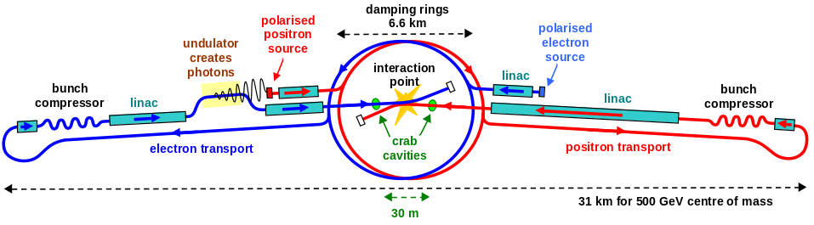

the linac
Linacs accelerate bunches of charge particles by arranging a time varying alternating electric field to point in the direction for acceleration (as opposed to de-acceleration) at the instant that bunches pass. Multiple cells are used to increase acceleration per unit length. The ILC linac frequency is 1.3 GHz.

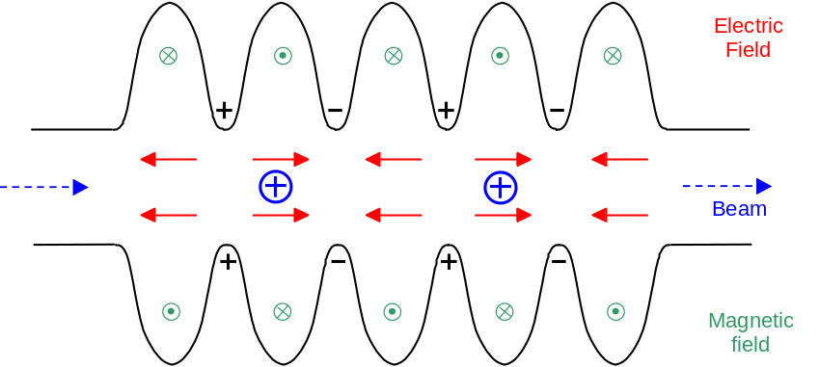

Maximising luminosity
As well as accelerating charged bunches it is also possible to excite cavities by driving them at a higher frequency so they deflect or impart angular rotation to charged bunches. As the linacs of the ILC are not aligned, bunches must be rotated into alignment to maximise the number of electron positron collisions at the IP. Cavities used to impart rotation are called Crab Cavities.

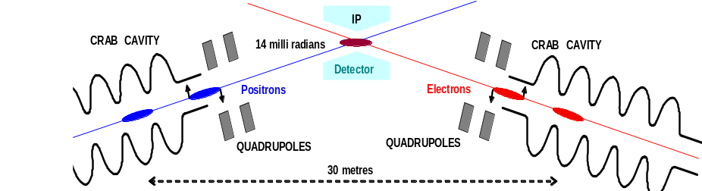

DIPOLE FIELDS IN CRAB CAVITIES
Cavities used to impart rotation are excited in a dipole mode. The ILC crab cavity frequency is 3.9 GHz. Depending on the time that a bunch enters the cavity it can either receive a transverse deflection or a rotation. Rotation occurs at a zero crossing of the field so that the front of the bunch is deflected one way and the back the other way. A particle that is deflected sees a transverse electric field in the iris and then a transverse magnetic field in the cavity centre. Because of the way the fields reverse and the phasing of the E and B fields the force is always in the same direction.


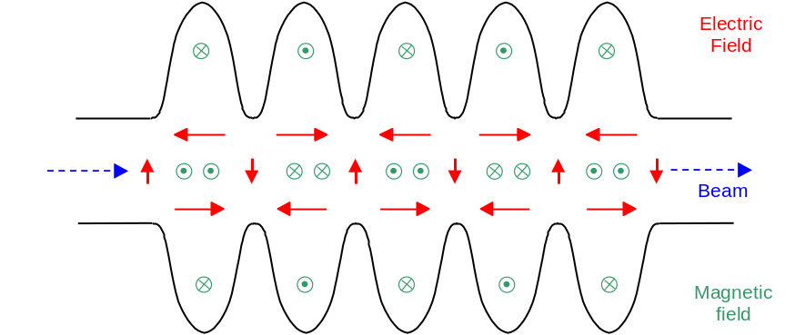
Cockcroft
Institute

superconducting cavities
To minimise electrical power usage, superconducting cavities were selected for the main linac. The optimal bunch structure for the ILC superconducting linacs (3000 bunches 330 micro-seconds apart) makes superconducting cavities the optimum choice for the crab cavities. Superconducting cavities are made of Niobium and are cooled in liquid Helium to 1.8 K. The R&D process demands the testing of cavities with a small number of cells before manufacture and testing the planned nine cell cavity (one cell and three cell cavities are shown below).

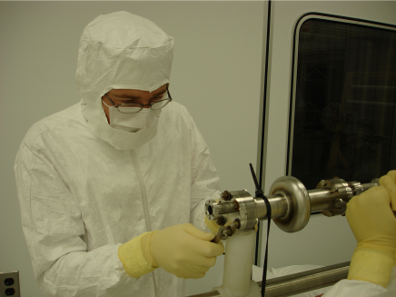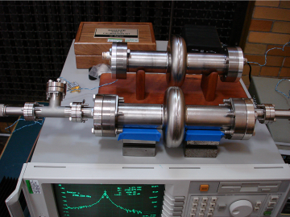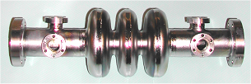

Couplers
The power that sets up the alternating electric fields in the cavities comes from special high power RF amplifiers, (Klystrons or IOTs). Power is transferred into the cavity down a metal pipe called a waveguide. If the pipe has a central conductor it is called a co-axial waveguide. The design of the interface at the cavity, called the coupler, is very critical for getting optimum power transfer into the cavity. Electromagnetic modelling is used to develop couplers.

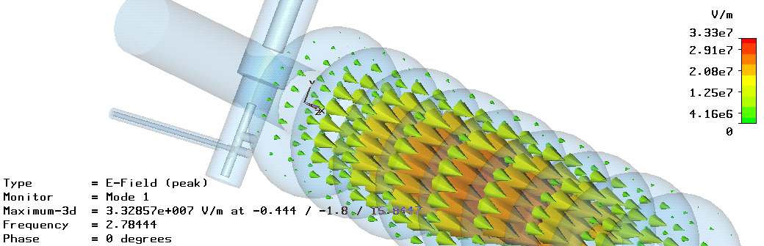

THE LOW LEVEL RF SYSTEM
A timing error on the phase of one of the cavities will result in the bunches missing each other. A local timing reference is established close to the output coupler of each cavity with an interferometer. The phase of the field in each cavity is sampled, compared to the timing reference and the error sent to a digital signal processor (DSP) to determine how the input signal must be varied to eliminate the error.




