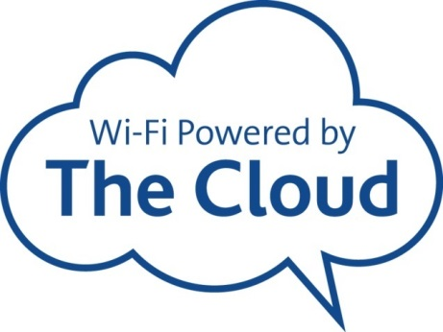

TheCloud@Durham

Visitors and non-academic guests should use ‘TheCloud@Durham’ to connect to the wireless service when visiting Durham University

About “TheCloud”
‘TheCloud’ is a free public access wireless service with thousands of hotspots and millions of registered users, it provides simple, fast and reliable wireless Internet access
'TheCloud' service is available for Android, iOS, Windows and Mac devices.

Get Connected
To connect to ‘TheCloud@Durham’ simply follow the steps below:
1. Switch on your smartphone, tablet or other Wi-Fi device and check that Wi-Fi is enabled.
2. Select 'TheCloud@Durham' from the available network list
3. Open your Internet browser - 'TheCloud' landing page below will appear. Click 'Get Online'.
4. You will then see the service selection screen. Select ‘The Cloud Wi-Fi'.
5. Once this is done you can either login with an existing 'TheCloud' account, or click on the 'Create Account' button to register for a free account.
6. Once you have logged in or registered you will be able to access the Internet using 'TheCloud@Durham'.

Security
For details on ‘TheCloud’ Wi-Fi Security', please visit this link https://www.skywifi.cloud/wifi-security/

Support
If you experience problems connecting to "TheCloud@Durham" please contact the IT Service Desk on 0191 334 1515
Follow this link: https://www.skywifi.cloud/faqs-support/ for FAQs

https://www.dur.ac.uk/cis/wireless/thecloud/

